**Pictures of the board (with the votes): -**

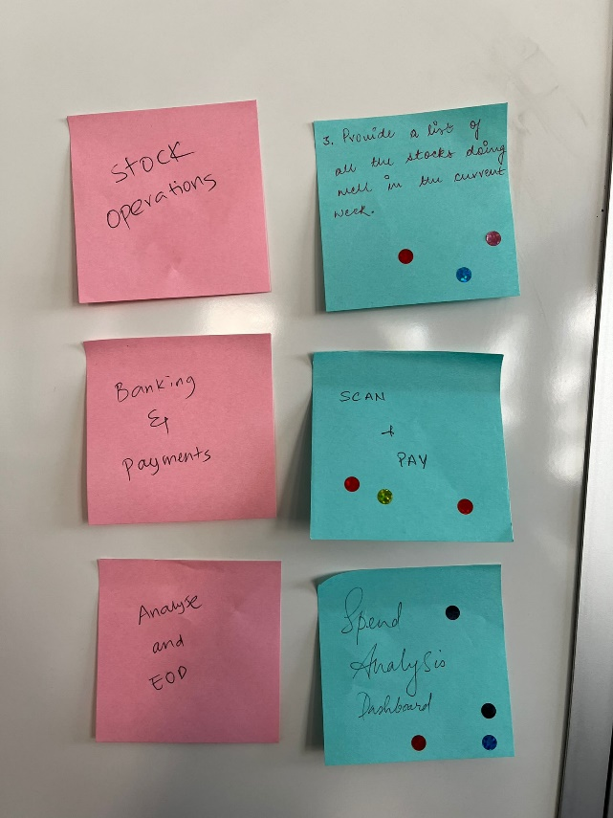

The concepts which were decided as our top choices were-

1. Provide a list of all stocks doing well in the current week:

* In a banking application, user would like to know about stocks that are performing well in that week to invest in them.
* It involves users who invest in stocks on daily basis to keep themselves updated about stocks that they might have not paid close attention to.
* This concept included several steps such as providing list of profitable stocks, viewing trends of scaling, buy/sell options, etc. Hence, we chose this concept.

1. Scan and Pay:

* A user could add his bank account to the application, thereby using it to transfer funds to an individual.
* User would make use of QR code scanner and pay the required amount to other person easily and efficiently.
* We chose this concept because it would help a user perform any operation to send/ receive money easy and quickly.

1. Spend Analysis Dashboard:

* A user would be able to view an overall summary of his investments, earnings, expenses in a single application.
* A dashboard would deliver maximum information via pictorial graphs and data, thereby helping the user to understand this very easily.
* This feature would make sure that user budgeting is carried out effortlessly.

Storyboards I created-

I conceptualized the Scan and Pay feature using storyboard technique. We ended up finalizing the storyboard of a combination of two students (me and Mahesh Chand). Below is my storyboard-

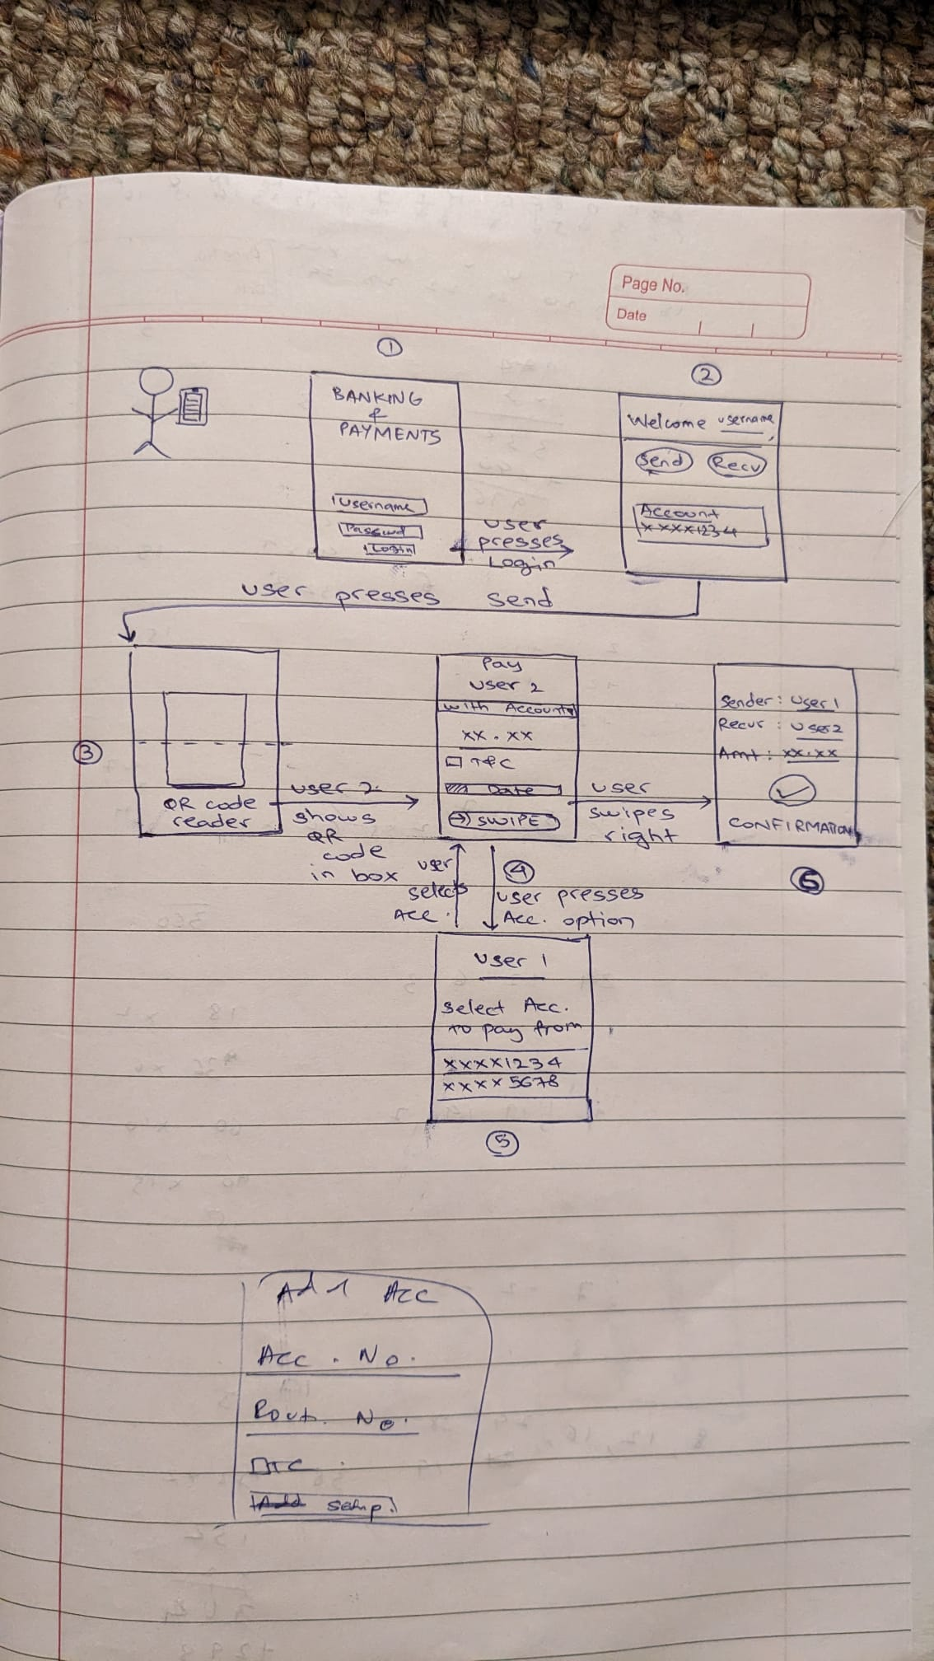

The prototype sketch that I created: -

`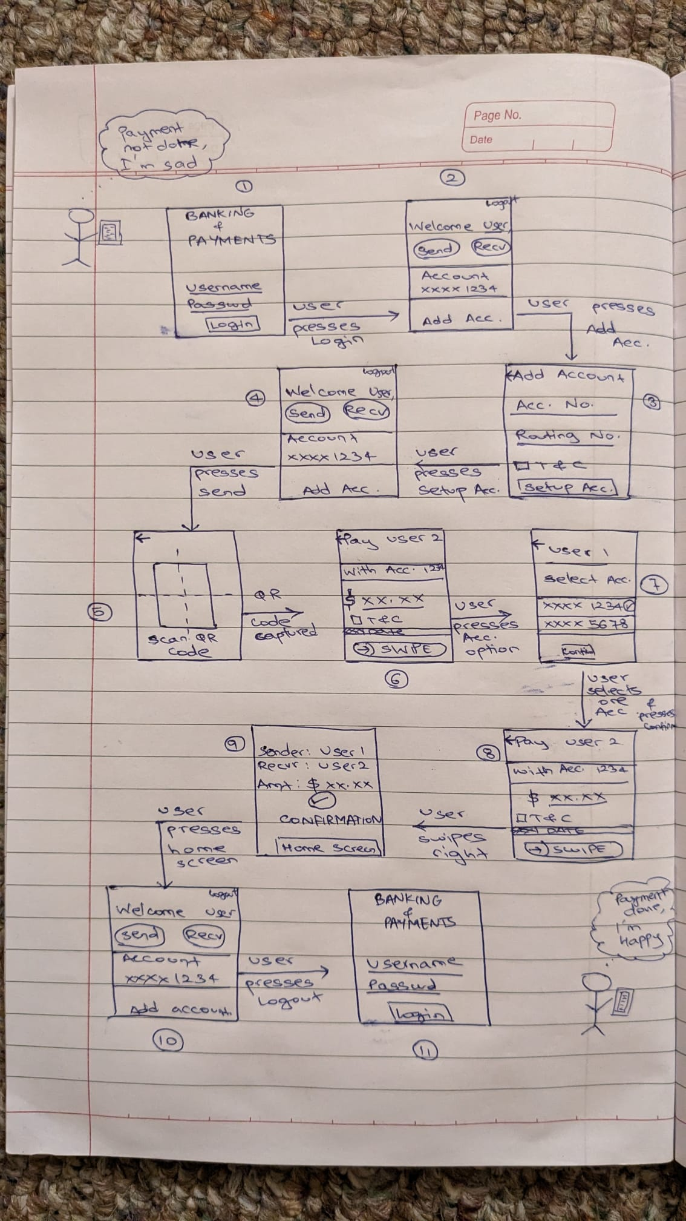

**Team Members-**

I worked with Avani, Rishabh, Jagadeep, Mahesh and Rudrajeet on building the concepts.

I worked with Jagadeep and Mahesh on building the storyboard and prototype.